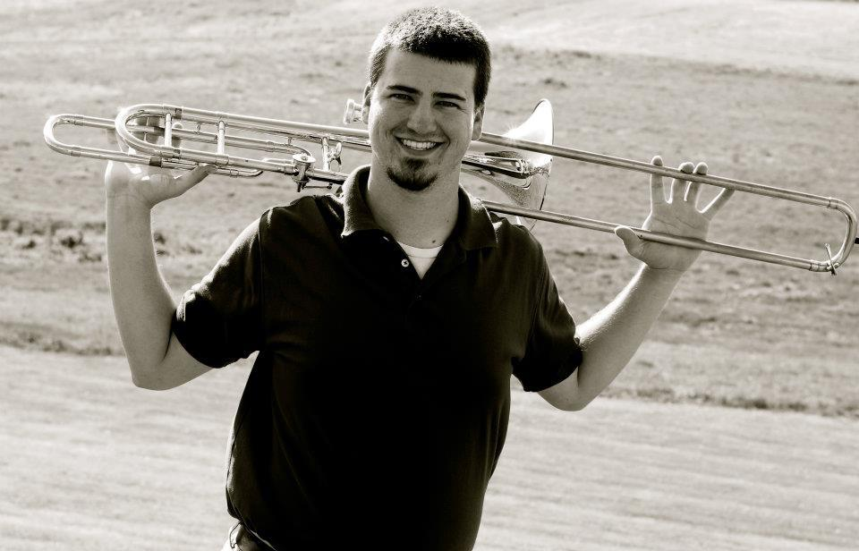
1200 Old Rixeyville Road, Culpeper VA
(540) 825-8358
  - An evening of Trombone with Kyle Remnant

Searching for Harmony
Kyle Remnant is a Master’s student studying Trombone Performance at James Madison University in Harrisonburg, Virginia. His Brethren faith is not only at the core of his music, but it has also led him to spread the message of peace and love. Kyle is a member of the Bridgewater Church of the Brethren and a graduate of Bridgewater College.

February 12, 2013 - 7PM

St. Luke Lutheran Church
Pastor: Kate Costa

